Random Inflation Questions
- Use the table to answer the following question.
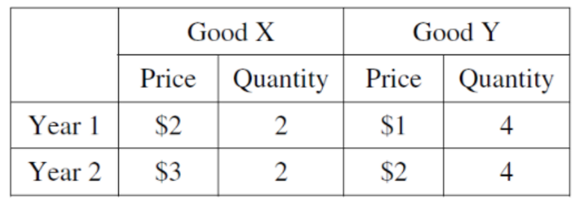
If an economy produces just two goods, what is the GDP deflator value for year 2?
- 57.1
- 66.7
- 100
- 175
- 250
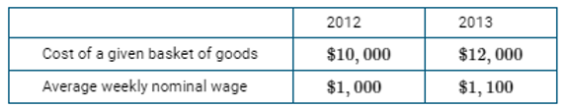
- Use the table to answer the following question.
If 2012 is the base year, which of the following is true?
- Inflation from 2012 to 2013 is 10%
- CPI in year 2013 is 110.
- The CPI in year 2013 is 120.
- Based on the CPI, the average real weekly wage increased by 10% from 2012 to 2013
- Based on the CPI, the average real weekly wage decreased by 20% from 2012 to 2013
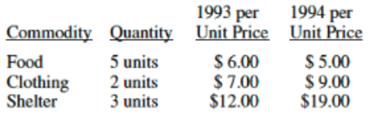
- Use the table to answer the following question.
The CPI from 1993 to 1994:
- Remained unchanged
- Decreased by 25%
- Decreased by 20%
- Increased by 20%
- Increased by 25%
- The CPI is criticized for
- Overstating the true burden of inflation because it does not recognize consumers’ ability to substitute goods and services as prices change.
- Overstating the true burden of inflation because it does recognize consumers’ ability to substitute goods and services as prices change.
- Understating the true burden of inflation because it does not recognize consumers’ ability to substitute goods and services as prices change.
- Understating the true burden of inflation because it does recognize consumers’ ability to substitute goods and services as prices change.
- Overstating the true burden of inflation because it does reflects the prices of both intermediate goods and final goods.
- Use the table to answer the question:
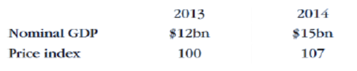
What is real GDP in 2014? (Assume 2013 is the base year.)
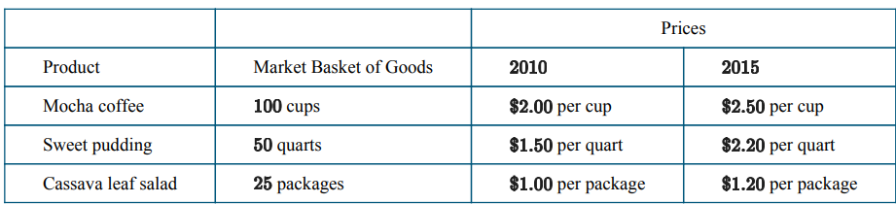
- Use the table to answer the question:

If we are given a table of this data, is it about the CPI or the GDP Deflator?

- True or False? Only the CPI and not the GDP Deflator is equal to 100 in the base year.

- True or False? Both the CPI and GDP Deflator are measures used by the government and other economic analysts to measure the level of inflation in the economy.

- If the CPI goes from 150 to 120, then prices have
- Risen 20 percent
- Risen 25 percent
- Fallen 20 percent
- Risen 25 percent
- Risen 150 percent
- According to experts, the CPI
- Overstates increases in the cost of living
- Understates increases in the cost of living
- Accurately estimates changes in the cost of living
- Could over or underestimate changes depending on the season
- Should be abandoned in favor of the GDP deflator

- If nominal GDP equals $5000 and real GDP equals $4000, the GDP deflator equals
- 125
- 1.25
- 800
- .8
- 300
- If nominal GDP equals $6000 and the GDP deflator equals 200, then real GDP equals
- 30
- 3,000
- 12,000
- 1,200
- 1,200,000
- Fisher's Hypothesis states that
(A) the real interest rate equals the nominal interest rate plus the inflation rate.
(B) the nominal interest rate equals the real interest rate minus the inflation rate.
(C) the nominal interest rate equals the unemployment rate plus the real interest rate.
(D) the nominal interest rate equals the unemployment rate minus the real interest rate.
(E) the nominal interest rate equals the real interest rate plus the inflation rate.

Answers
1 | D | 6 | Probably CPI because refers to a basket | 11 | A
2 | C | 7 | False, both are. | 12 | B
3 | E | 8 | True. | 13 | E
4 | A | 9 | C | 14
5 | 14.01 bn | 10 | A | 15

